Ticket ID: TK-01

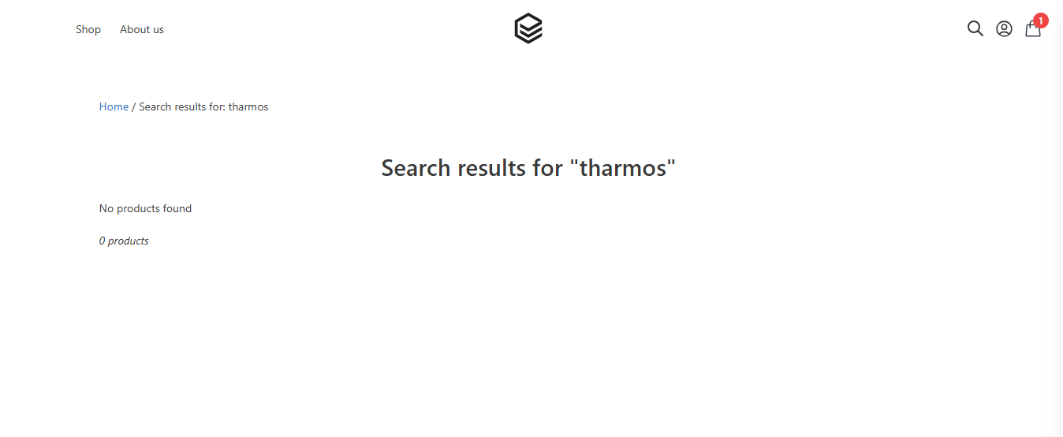
I put only one character as a wrong word in the search box (thermos —-> tharmos), but there is no suggestion for the correct suggestion.

Ticket ID: TK-02
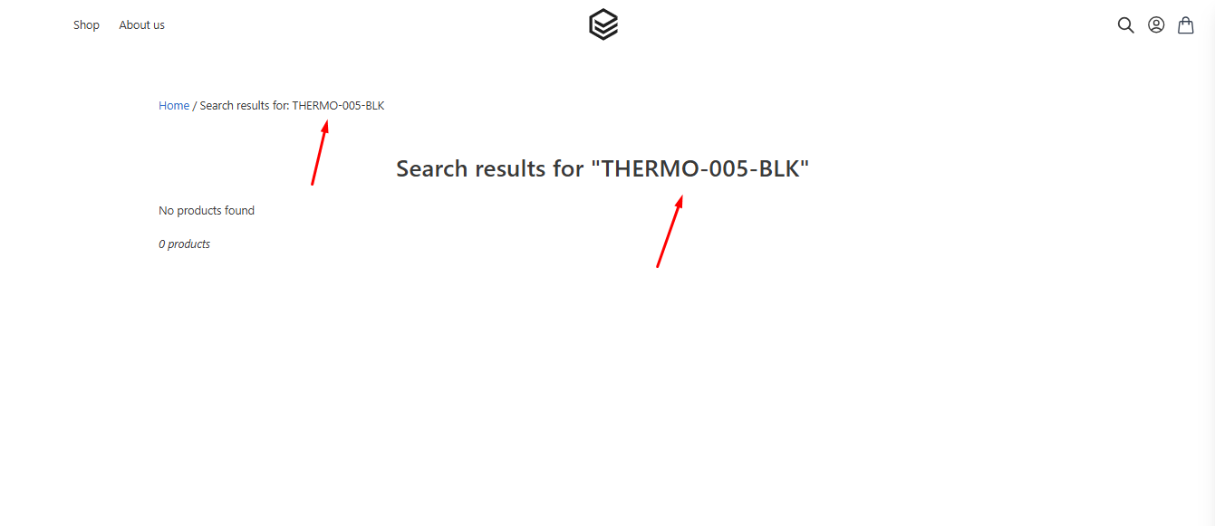

Ticket ID: TK-03
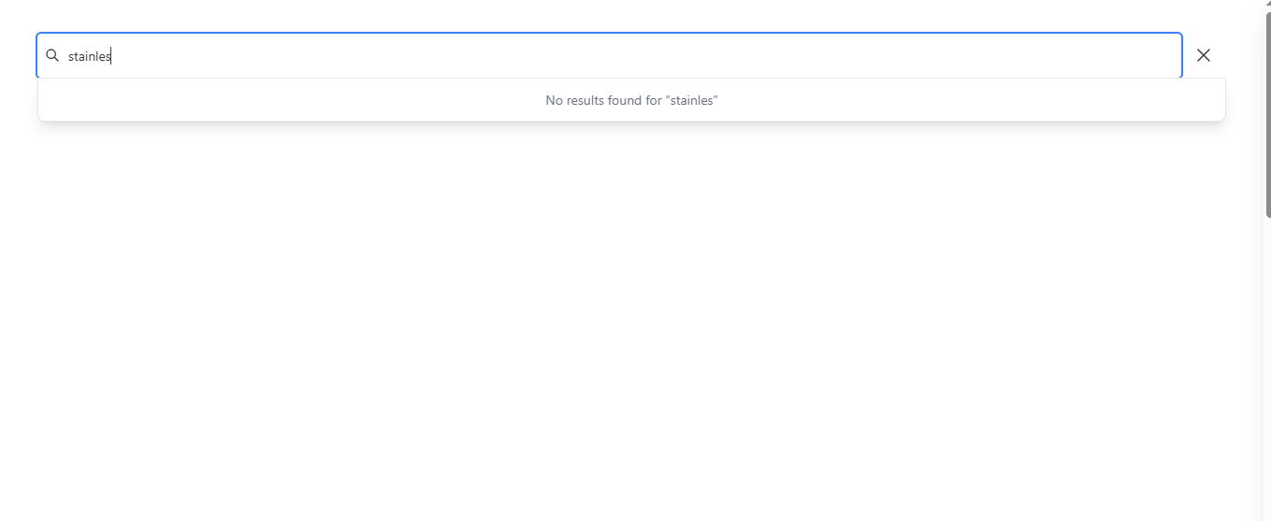
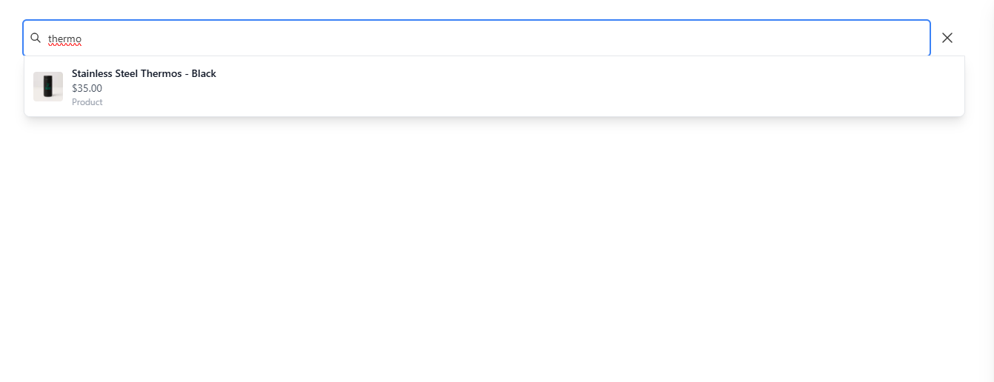
Here two search results are included. One keyword is not showing as a matching word and the other one is working.

Ticket ID: TK-04

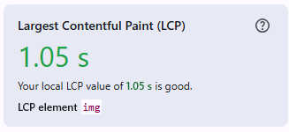
Loading time without any throttling.

Ticket ID: TK-05
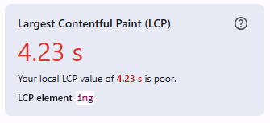
Page loading time on 3G Network was 4.23 seconds.

